September 11, 2019  TO: Principal  High School  FROM: Washington DC Hall of Fame Society, Inc.,  Jack H. Olender Leadership Academy  Wednesday, October 29, 2019 at the historic Charles Sumner School  SUBJECT:  Invitation to the TENTH Leadership Academy for DC Public High School Students | 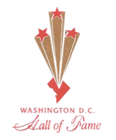

The Washington DC Hall of Fame Society is celebrating its 20th anniversary and, this year, also celebrates its 10th Leadership Academy for DC high school students. The purpose of our organization is to honor long-time Washington DC residents with induction into the Hall of Fame. Hall of Famers laid the foundation for the growth and development of our City. These distinguished Honorees have made a tremendous impact in education and politics, community, and economic endeavors of our City. Over the years, the DC Hall of Fame has also awarded scholarships to District residents graduating high school to support their attendance at a post-secondary program of their choice.

On Wednesday October 23, 2019, we will launch our TENTH Washington DC Hall of Fame Leadership Academy. It would be an honor to have you select interested senior and junior grade students to experience our Academy as they embark on the next stage in their lives. The Jack H. Olender Leadership Academy will take place from 10:00 am to 2:00 pm at the Charles Sumner Museum and Archives at 1201 17th Street, NW, third floor, Washington, DC. (Lunch included.) Transportation will be provided using a vendor approved by DCPS for the 2019-2020 school year.

During this event, high school students will be able to meet with several of our Hall of Famers to discuss career choices and future goals. Our Hall of Famers are experts with 30 to 50 years of experience in a variety of fields: Business, Civic/Community, Culture & Arts, Communication, Education, Health, Law, Politics/Government, Science/ Technology/ Architecture/Engineering and Sports. As well, high school students will be able to meet with several Trailblazers, panelists at earlier stages in their careers.

Our Hall of Famers include: Former Mayors Anthony Williams and Sharon Pratt; Kojo Nnamdi (Wamu), Joseph Davidson (Washington Post); Bruce Johnson, Andrea Roane (Channel 29); Fred Valentine, Lucille Hester and Bobby Mitchell (Sports); Attorneys Jack Olender, Judge Rufus King, Judge Mary Terrell, Tuskegee Airman Joseph Hairston; Carole Schwartz, Kerwin Miller, Esq., Government; A. Barry Rand, Chairman, AARP; Dr. Patricia Davidson, Dr. Roselyn Epps, Dr. Sharon Malone (Health); Courtland Cox, Paul Cohen, and Jan Adams, Business; Dr. Marilyn Brown, Romaine Thomas, Education; Aprille Ericsson, NASA; Therrell Smith (CulturalArts).

Students participating in this activity will qualify for a certificate providing 2 hours of community service, in addition to meeting distinguished elders of the DC Community.

We look forward to hearing from you and welcome the opportunity to talk with you about the Leadership Academy.

Please share this announcement with Counselors and Teachers.

Please return the REGISTRATION FORM by Friday, October 11 with the names, grade levels and career interests of the students who will attend. Dr. Toby Horn, Academy Director, tmh20009@gmail.com or wdchalloffame@gmail.com, 202-365-3980.

Toby M Horn, Ph.D.
Director, Jack H. Olender Leadership Academy

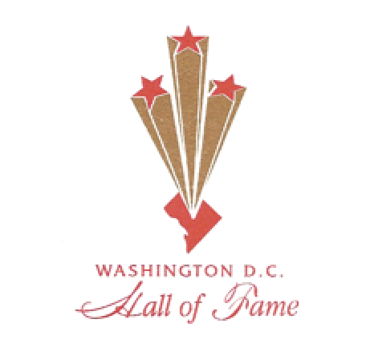 | Registration Form  Washington DC Hall of Fame Society, Inc.  Jack H. Olender Leadership Academy  Wednesday, October 23, 2019  Historic Charles Sumner School, 1201 17th St, NW  10:00 AM to 2:00 PM

RSVP by e-mailing this Form to Dr. Toby Horn, tmh20009@gmail.com

PLEASE REPLY by Friday, October 11, 2019.

School:
Chaperone Name: |  | School Role:
e-mail: |  | CellPhone (to finalize bus pick-up)+:
Dietary Restriction?
+Bus will arrange to arrive at your school around 9 AM, but time may vary since one bus may transport groups from 2 or 3 schools.
 | Student Name PLEASE PRINT  (First Last) |  | Grade Level | Career  Interest | Dietary Restriction?*:  P no pork V Vegan  G Vegetarian N None
1
2
3
4
5
6
7
8
9
10

*The caterers will do their best to accommodate dietary restrictions.
Washington DC Hall of Fame
Jack H Olender Leadership Academy

Wednesday, October 23, 2019
Historic Charles H. Sumner School
Washington, D.C.

Dear ___________________________________________________________________,

Student Name

You have been selected to participate in the 10th Jack H Olender Leadership Academy of the Washington DC Hall of Fame on Wednesday, October 23, 2019.

This event is a special opportunity for you to meet the District of Columbia’s distinguished Hall of Famers to find out about their life paths and discuss your own career goals! You will also meet Trailblazers who are at early stages in their career paths for a panel discussion.

Round-trip transportation between your school and the Sumner School will be provided by a DCPS approved bus company. Lunch will also be provided.

When you return this form, please provide the information requested on the Registration Form to your school contact/counselor.

Please sign here to grant permission to be photographed during the DC Hall of Fame Leadership Academy. Your image may appear on the website for the Washington DC Hall of Fame: https://www.dchalloffame.org

I grant permission for my child/self (if you are 18) _________________________________________ to be photographed during the DC Hall of Fame Leadership Academy. Print Student’s Name, please

Printed Name of Parent/Guardian: __________________________________________DATE:____________________

Signed_____________________________________________________ (Parent/Guardian/Self if you are 18)

Please return this letter to the school person who gave you this invitation by Monday, October 7.

The school contact will be in touch with you with further instructions about when the bus will arrive on October 23 to transport you and your schoolmates to the Historic Charles Sumner School. Please plan to arrive at your school on time on Wednesday, October 23.

Our Hall of Famers include: Former Mayors Anthony Williams and Sharon Pratt; Kojo Nnamdi, WAMU; Joseph Davidson, Washington Post, Bruce Johnson, Andrea Roane, Channel 9; Fred Valentine, Bobby Mitchell and Lucille Hester (Sports); Jack Olender, Judge Rufus King and Tuskegee Airman Joseph Hairston, Attorneys; Judge Mary Terrell; Maudine Cooper, Urban League, Kerwin Miller, Government; Dr. Patricia Davidson, Dr. John Robinson, Dr. Sharon Malone, Health; Courtland Cox, Jan Adams, and Deryl McKisssack, Business; Aprille Ericsson, NASA; and many more.

We look forward to meet you on Wednesday, October 23, 2019, at the Washington DC Hall of Fame Leadership Academy!

Sincerely yours,
Toby Horn, Ph.D., Director, Jack H. Olender Leadership Academy

